

**DEPARTMENT OF ELECTRONICS AND COMMUNICATION ENGINEERING**

**RCC Institute Of Information Technology**

**Affiliated to Maulana Abul Kalam Azad University of Technology , West Bengal**

**Canal South Road, Beliaghata , Kolkata-700015**

**Q. Design a BCD to 7 segment decoder using Logic gates(c & d) .**

**THEORY:**

Theory-This decoder accepts the BCD code and provides output to energize seven segment display devices in order to produce a decimal read out. Sometimes, the hex characters A through F may be produced. Each segment is made up of a material that emits light when current is passed through it . The most commonly used materials include LEDs, incandescent filaments and LCDs . The LEDs generally provide greater illumination levels but require more power than that by LCDs.

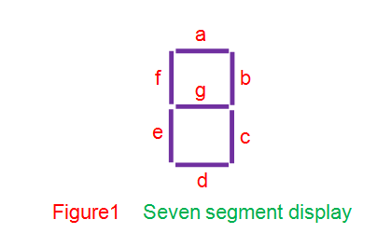

This figure shows a seven segment display consisting of seven light emitting segments. The segments are designated by letters a-g . By illuminating various combinations of segments the numbers 0-9 can be displayed

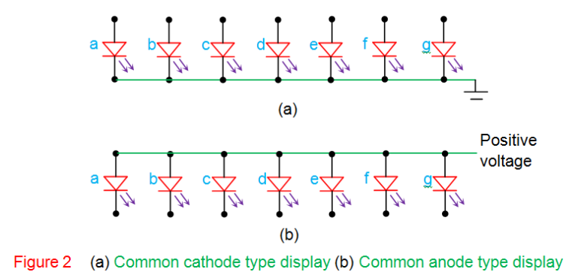

This figure shows two type of LED display – the common-anode and the common-cathode type.In the common anode type , a low voltage applied to an LED cathode allows current to flow through the diode, which causes it to emit light. In the common-cathode type , a high voltage applied to an LED anode causes the current to flow and produces the resulting light emission .

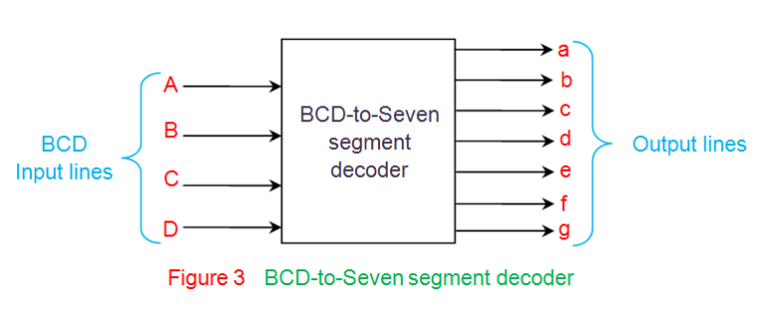

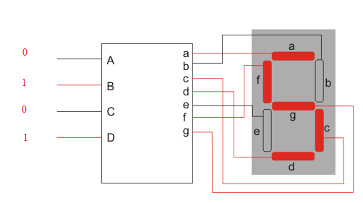

An 8-4-2-1 BCD to seven segment decoder logic circuit is shown . Since a 1(High) on any output line activates that line, we assume that the display is of common-cathode type.

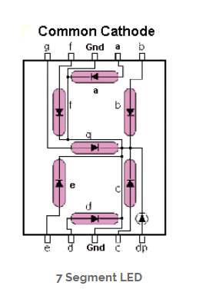

**SOFTWARE REQUIRED:** *Proteus Design Software*

**DESIGN:**

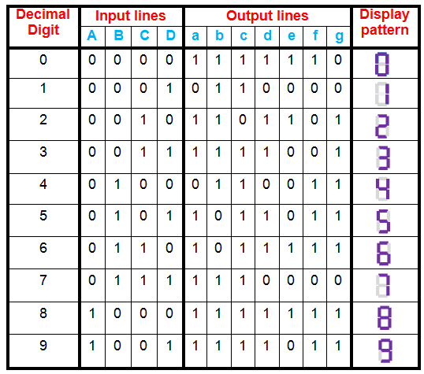

From the above truth table, the Boolean expressions of each output functions can be written as

a = F1 (A, B, C, D) = ∑m (0, 2, 3, 5, 7, 8, 9)

b = F2 (A, B, C, D) = ∑m (0, 1, 2, 3, 4, 7, 8, 9)

c = F3 (A, B, C, D) = ∑m (0, 1, 3, 4, 5, 6, 7, 8, 9)

d = F4 (A, B, C, D) = ∑m (0, 2, 3, 5, 6, 8)

e = F5 (A, B, C, D) = ∑m (0, 2, 6, 8)

f = F6 (A, B, C, D) = ∑m (0, 4, 5, 6, 8, 9)

g = F7 (A, B, C, D) = ∑m (2, 3, 4, 5, 6, 8, 9)

**The K-Maps used to simplify the logic expression for driving the segments are shown.**

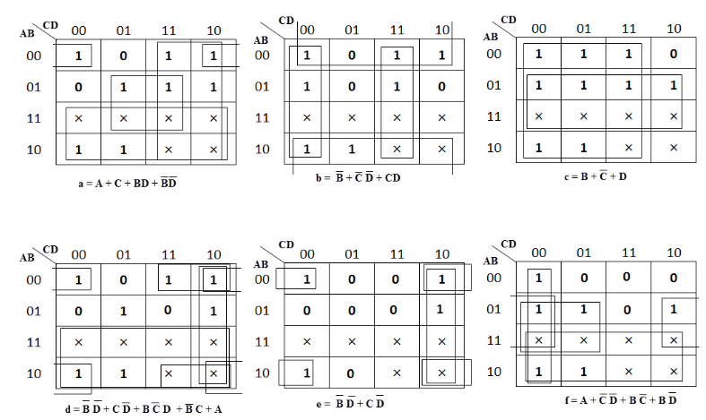

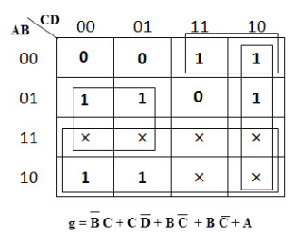

**CIRCUIT:**

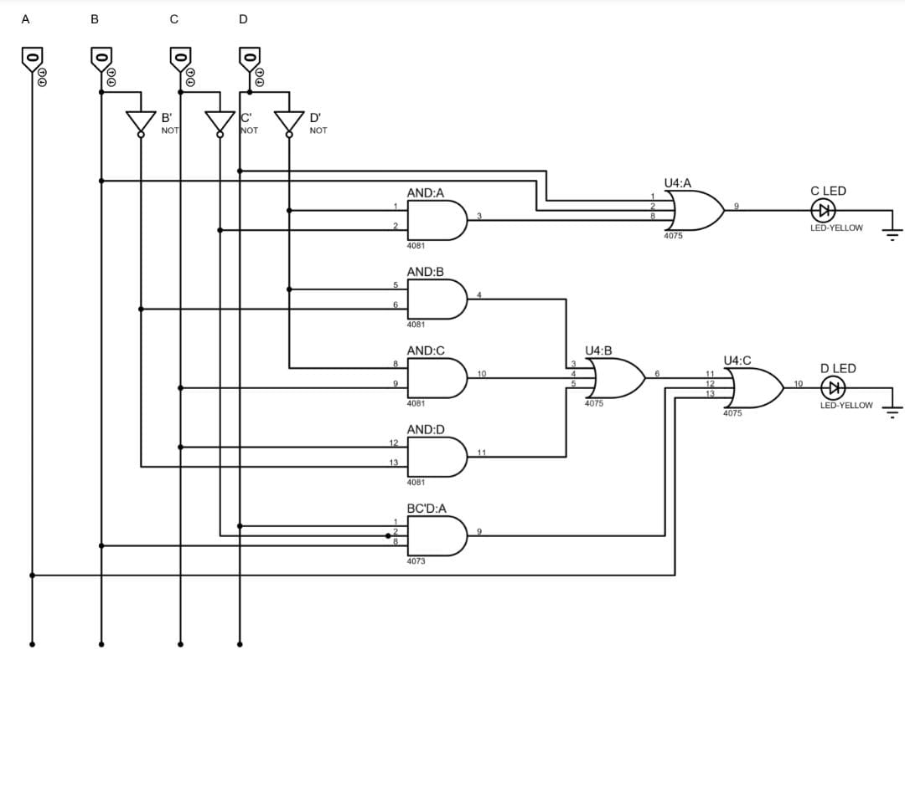

**OUTPUT:**

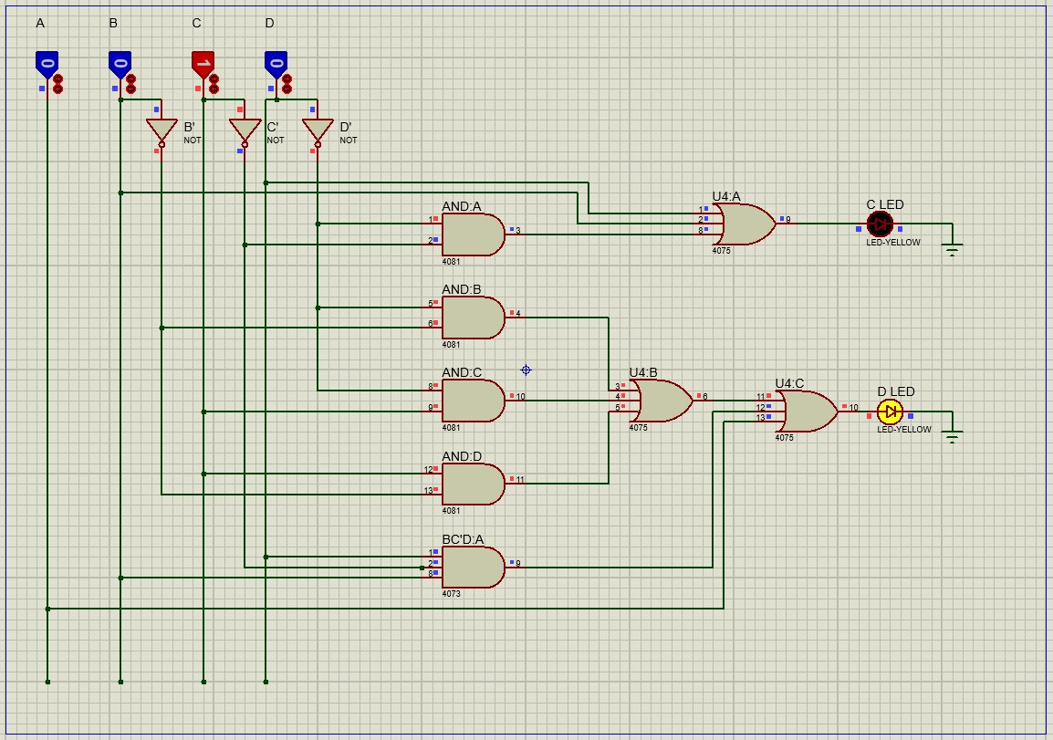

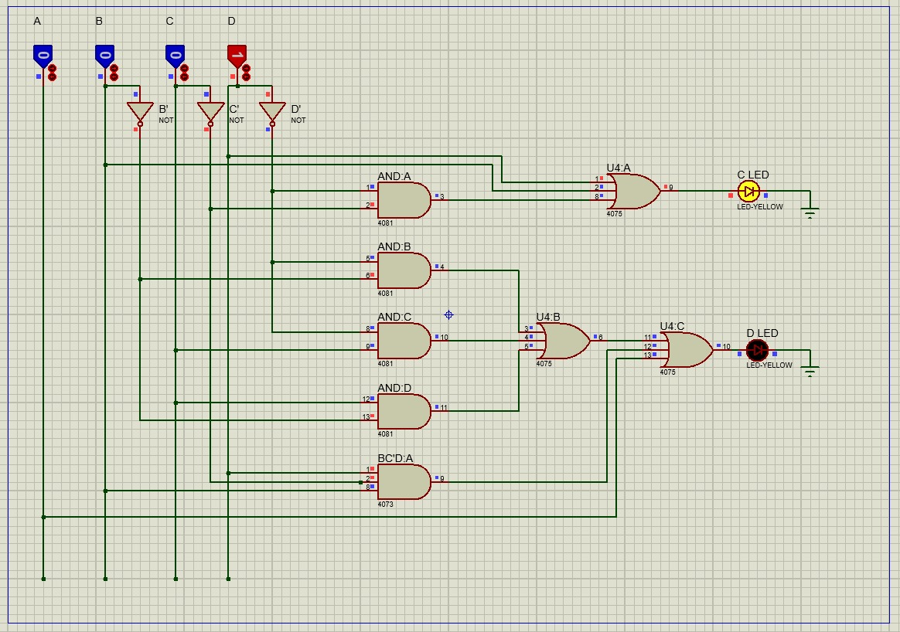

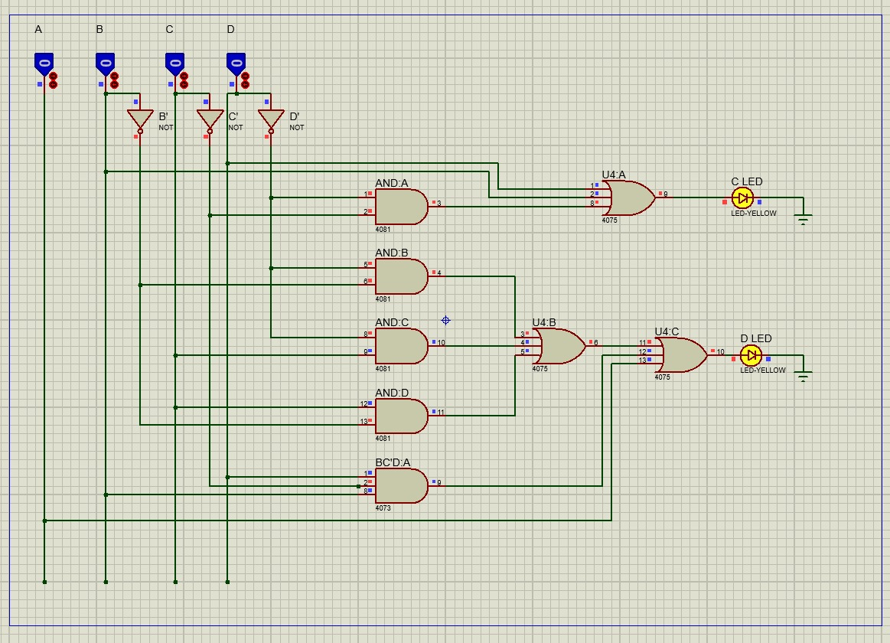

**CONCLUSION:**

We have successfully implemented the BCD to seven segment display (c and d) and verified the output.